|  |  |
| --- | --- |
|  | **IoT Korea Exhibition 2017**  Oct. 11(Wed)~13(Fri), 2017 / COEX, Seoul, Korea |

|  |  |  |  |  |  |  |  |  |  |
| --- | --- | --- | --- | --- | --- | --- | --- | --- | --- |
| **1. Exhibitor information** | |  |  |  | |  | |  |  |
| **Company Name** |  | | | | | | | | |
| **Address** | **Zip Code ( - )** | | | | | | | | |
| **Tel** |  | | | | **Fax** | |  | | |
| **Website** | **www.** | | | | | | | | |
| **Contact** |  | | | | **Title** | |  | | |
| **E-mail** |  | | | | **M.P.** | |  | | |

|  |  |  |  |
| --- | --- | --- | --- |
| **2. Booth type & Price Information**[1booth : 3mx3m= 9sqm] | | |  |
| **Booth Type** | **Raw Space**  (Min. size 2booths) | **Shell Scheme Package**  (Min. size 1booth) | |
| **Price** | USD 2,500 / 1booth | USD 3,000 / 1booth | |

|  |  |  |  |  |
| --- | --- | --- | --- | --- |
| **3. Participation Fee for Exhibitions Space** | | | | |
| **Booth Type** | **Booth Quantity** | | **Total** | |
| **▪ Raw Space** |  | Booth(s) | USD |  |
| **▪ Shell Scheme Package** |  | Booth(s) | USD |  |

|  |
| --- |
| **4. Products to be exhibited** |
|  |
|  |

**5. Payment Schedule**

The Exhibitor agrees to the following payment Schedule :

- 50% of Total amount should be paid within 7 days.

- The final balance should be paid no later than August. 25, 2017.

|  |  |  |  |  |  |  |
| --- | --- | --- | --- | --- | --- | --- |
| **Name** |  | | **Title** |  | **Date** |  |
| **Authorized Signatory**  **& Company Stamp** | |  | | | | |

IoT Korea Exhibition 2017 Organizer Office l Tel : +82-2-555-7153 , E-mail. jykoo@kfairs.com

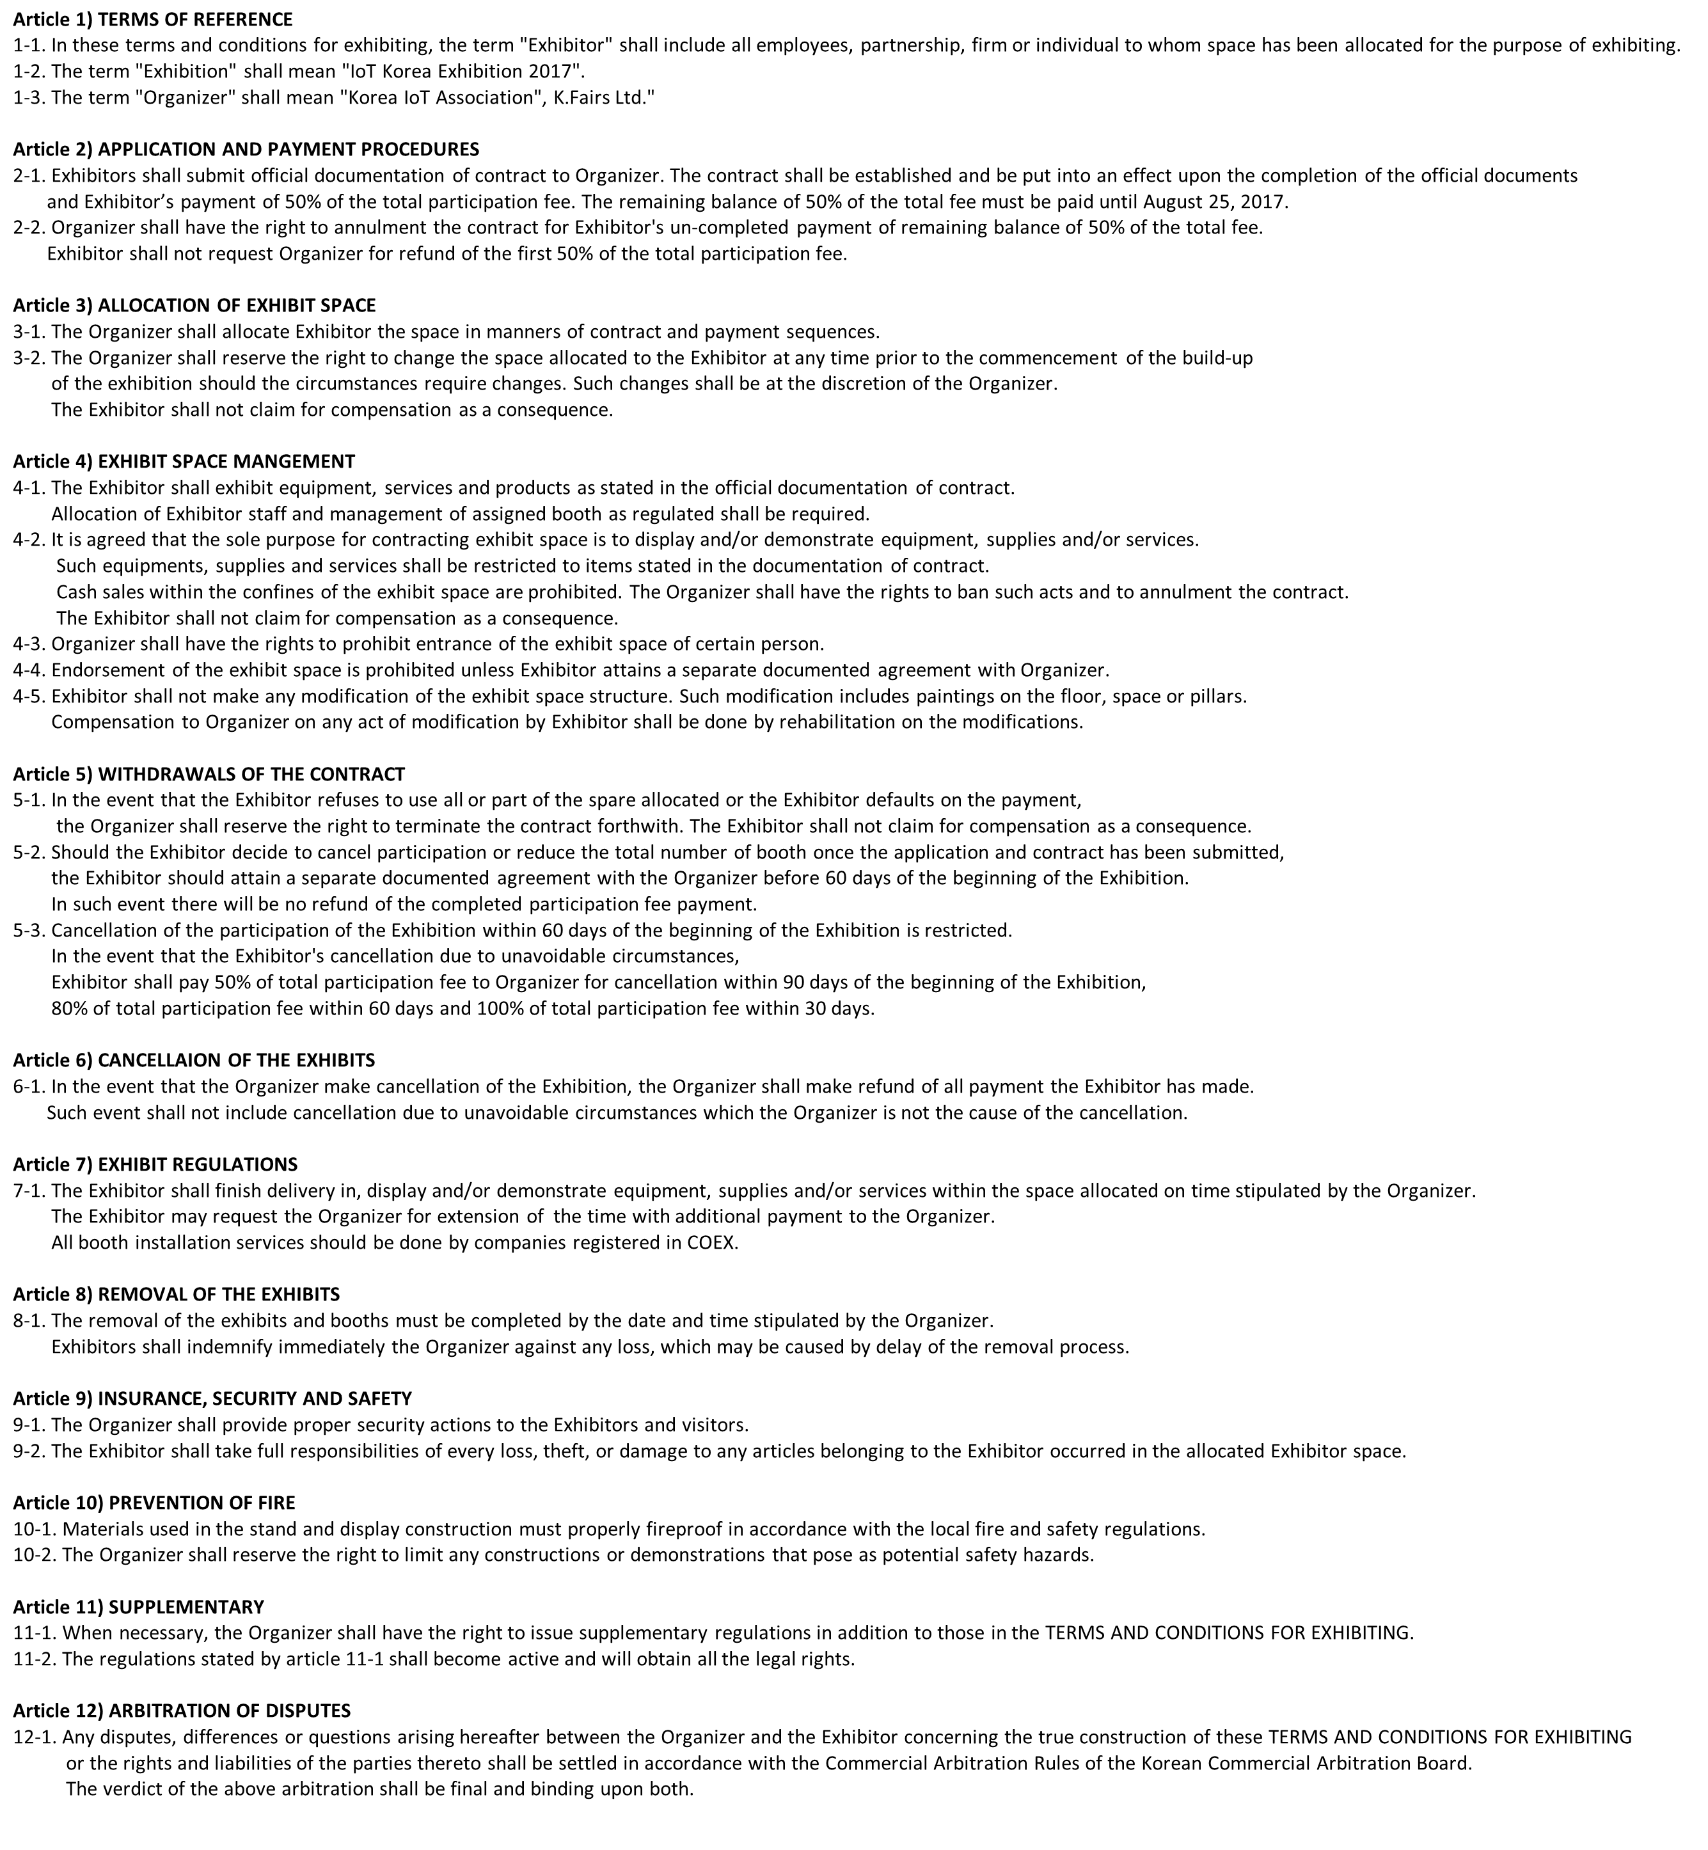

IoT Korea Exhibition 2016 Organizer Office l Tel : +82-2-555-7153 , E-mail. jykoo@kfairs.com